IE 212: Computational Methods for Industrial Engineering
Winter 2013

Homework #4: Writing sub procedures

Due Date: Tuesday, February 5th, 2013

IMPORTANT NOTES:

To obtain full credit in this homework, you must:

- Submit a single Excel file via The Engineering Accounts & Classes (T.E.A.C.H.) homepage (http://engr.oregonstate.edu/teach).
  - Before submitting your file via T.E.A.C.H., make sure the sample data provided for each problem is in the format it was BEFORE you wrote your sub procedures. This will simplify grading for the TA.

- Solutions for each individual problem should be prepared in separate worksheets.
  - Show all your work in each problem.
  - Make sure to follow good programming practices, especially indenting and commenting your code.

- Submit a hard copy of the last page included in this document at the beginning of the lecture session on Thursday, January 31st.
  - Do not forget to add your name and your grader's last name electronically to this page.

*** YOU MUST FOLLOW THE INSTRUCTIONS ABOVE TO OBTAIN
FULL CREDIT ON THIS ASSIGNMENT***
PROBLEMS

Open an Excel file and save it as “YourLastName_Hmw4.xlsm.” DO NOT FORGET TO SAVE YOUR FILE AS A MACRO-ENABLED FILE. Delete "Sheet3" from the workbook and rename "Sheet1" and "Sheet2" as "Prob1" and "Prob2," respectively. Add a module in the Project Explorer and write (do NOT record) all your sub procedures inside this module.

Problem 1 (20 pts)

Table 1 shows the names of guests invited to a company’s picnic at an amusement park. Table 1 also shows the department each guest belongs to and how many people are coming with them (broken down by adults and children). The cost of each ride is $4 per adult and $2 per child. There are 9 rides for adults and 7 rides for kids. Manually enter the data exactly as shown in Table 1 into worksheet "Prob1." You can format the cells manually (i.e., not via code) in Excel.
Table 1. Data for Problem 1.
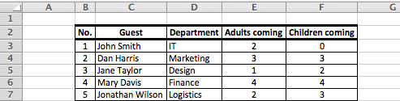

Write a single sub procedure named Picnic that will format the data and calculate the values as described in Table 2.
Table 2. Data Formatting Instructions for Problem 1.
Label | Calculation | Cell Fill Color |  | Font Color & Type
(H2:H4) | (I2:I4) | (H2:H4) | (I2:I4) | (H2:H4) | (I2:I4)
Total Number of Guests | Total sum | None | Yellow | Black, Bold | Black, Underlined
Total Cost of Picnic | (Total sum of adults * Cost per adult * Number of rides for adults) + (Total sum of children * Cost per child * Number of rides for children) | None | Red | Black, Bold | Yellow, Bold
Average Size of Party per Guest | Average | None | Blue | Black, Bold | White, Italic

SOLUTION REQUIREMENTS:

  - The Offset property MUST be used to position all labels and calculations in their respective cells. You may use any cell in the worksheet "Prob1" as the reference cell to use the Offset property.
  - Assign the sub procedure to a shape button. The button’s caption should read Calculate Statistics. The button should be visually appealing and its upper left corner should be aligned with the upper left corner of cell K2.
  - After the button is clicked, the display of the first calculation (i.e., Total Sum), its label and its corresponding cell’s formats should be delayed 3 seconds. The display of every subsequent calculation (and corresponding label and formats) should then be delayed 2 seconds.
  - The text “DONE!” should be displayed in cell H7 one (1) second after the last calculation is displayed. Use capital letters and BOLD font style for this legend.
  - Range H2:I7 should be cleared automatically by your procedure every time it is run.
- You must use the WITH construct to make your code more readable.
- Your sub procedure should end by selecting cell A1.
Problem 2 (20 pts)

Manually enter the data exactly as shown in Table 3 in columns B, C, and D, E, and F, respectively, of worksheet "Prob2." The upper left corner of Table 3 (i.e., the label "Rank") should be entered in cell B2.

Table 3. Data for Problem 2
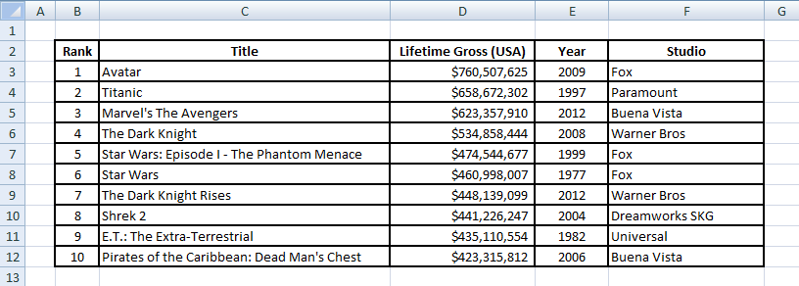

SOLUTION REQUIREMENTS:

- Write a sub procedure named Movies that will:
    - Use the Columns property of the Range object to give each column of the table its own background color. You are at liberty to pick the color for each column.
    - Copy the data in columns Title, Lifetime Gross (USA), and Year using the End property and paste it in range H2:J12.
    - Assign the sub procedure to a shape button. The button’s caption should read GROSS EARNINGS BY MOVIE. The button should be visually appealing and its upper left corner should be aligned with the upper left corner of cell B15.
    - Ensure that no flashing border remains after the copy-pasting operation is complete.
    - Ensure that no flickering occurs when you run your sub procedure.
    - Your sub procedure should end by selecting cell A1.

- Write a sub procedure named Clear_Movies that will:
- Clear range H2:J12.
- Assign the sub procedure to a button. The button’s caption should read CLEAR. The button should be visually appealing and its upper left corner should be aligned with the upper left corner of cell E15.

IE 212: Computational Methods for Industrial Engineering
Winter 2013

Homework #4: Writing sub procedures

Due Date: Tuesday, February 5th, 2013

Student Name:

TA Notes:

